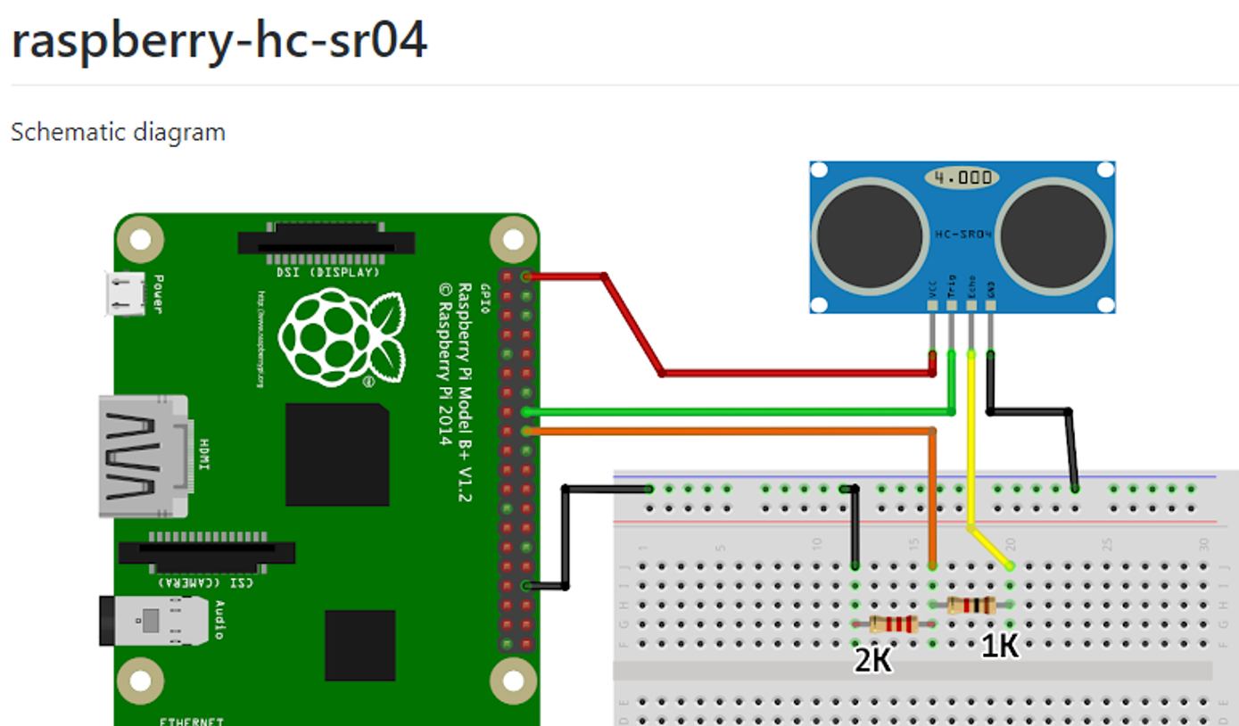

**HANDOUT 1**

PIN 24

PIN 23

GND

5V

Reference Material : <https://thepihut.com/blogs/raspberry-pi-tutorials/hc-sr04-ultrasonic-range-sensor-on-the-raspberry-pi>

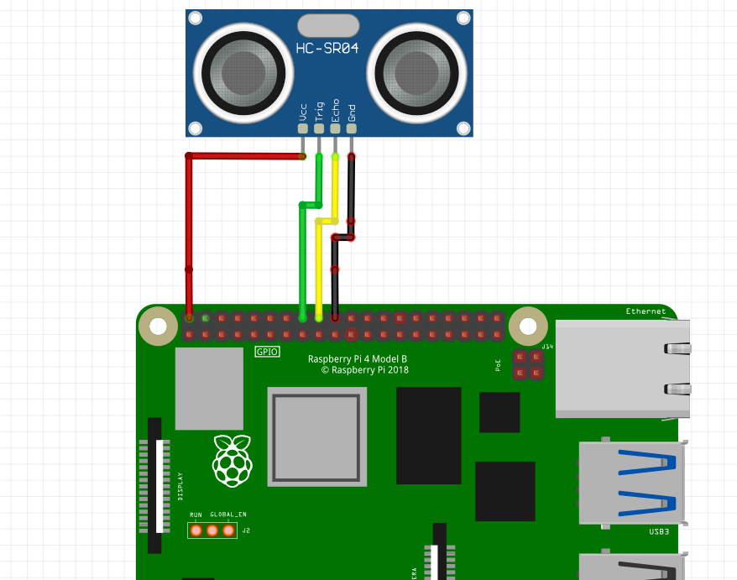

**HANDOUT 1A**

VCC 5V

GROUND

PIN 24

PIN 23